

Cardonald Primary School

Telephone: 0141 883 9668

Term 1 Newsletter: August 2024

**

*We are delighted to welcome all the children and staff back to school for another year of exciting events and fantastic learning experiences.*

*A very warm welcome to our new families.*

*This newsletter contains a number of important reminders and information for the year ahead. Please contact the school or visit our school website if you require any further information.*

*If you have any issues you wish to discuss with your child’s Class Teacher or the Leadership Team please make an appointment via the school office.*

*Mrs Waddell (Depute Head Teacher) will have responsibility for P1-P4*

*Miss Mohd (Depute Head Teacher) will have responsibility for P5-P7*

 Follow us on twitter: @CardonaldPri

 <http://www.cardonald-pri.glasgow.sch.uk/>



****Reporting your child’s absence**

You have a legal requirement to ensure your child is attending school on a regular basis. Attendance under 90% disrupts children’s learning. We will have a bigger focus on attendance at Cardonald this year and will be celebrating those with excellent attendance.

We understand there are times when absence is unavoidable. Please refer to the latest guidance below or contact your GP / local pharmacy if you are unsure .

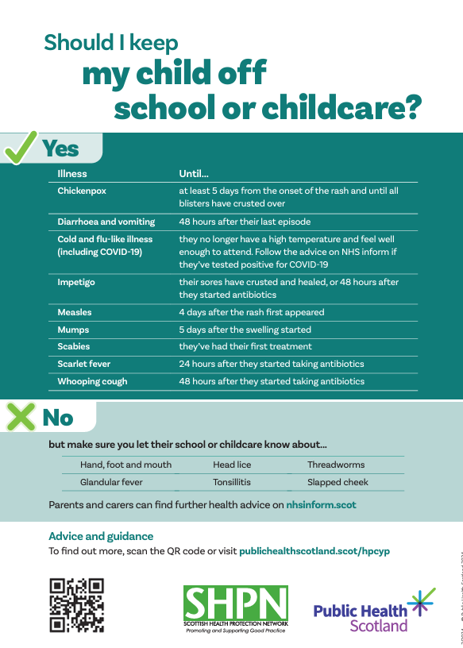

If your child is absent you have a parental responsibility to inform the school by 9.30am via

***Pupil Absence Reporting Line on 0141 287 0039***

If your child is going to be absent please call the ‘Absence Reporting Line’. If the reason for absence is personal or you feel the school requires more information about the absence please call the school directly. If you have not made contact, the school will try to contact you via text. If the school is unable to contact you, child protection procedures will be put in place to ensure the safety of your child. Your child’s safety and well-being is our priority. We appreciate your support with this matter.

You can now also report absence via an **online form**. Please read the form on the next page for a detailed explanation of this.

This is the link for the online form:

[**https://www.glasgow.gov.uk/pupilabsence**](https://www.glasgow.gov.uk/pupilabsence%20)

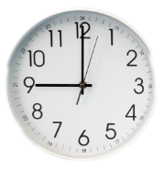If a child is persistently absent or late this matter will be investigated and appropriate action taken.

**Appointments**

If your child is required to attend an appointment during school time please inform the school office.

**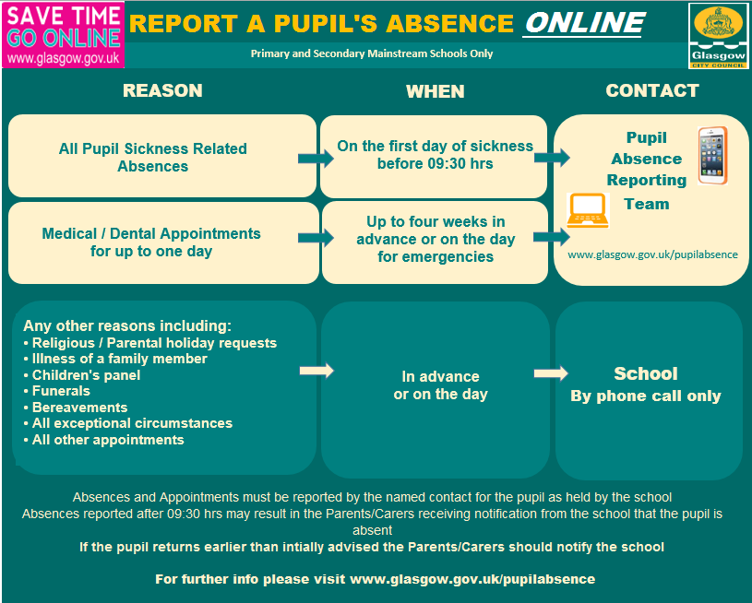

**Remember school begins at 9.00am**

**Support your child to be on time. Late-coming disrupts learning.**

**Groupcall**

We have been using Groupcall to send texts, emails and information to those who have the Xpressions app. This service is a valuable cost saving tool for the school to help keep you informed and relies on parents keeping their contact information up to date with the school. The Xpressions app in particular allows us to send information letters and attachments, reducing paper and is free of charge to the user. We would encourage you to **download the app by accessing http://parents.groupcall.com/**

**Breakfast Club**

Breakfast Club is provided by Glasgow City Council catering staff between 8.00-8.45am every morning. Breakfast Club costs £2 for your first child and £1 thereafter for additional children you have.

**Healthy Snacks**

****Please ensure your child has a healthy snack and lunch. Children will not be allowed to have more than 1 snack at playtime. Encourage your child to make healthy choices for snacks. Remember **no fizzy** drinks or chewing gum please!

**Pupils are also encouraged to drink plain water in the classroom to keep hydrated.**

**Juice or flavoured water is not allowed in the classroom. This can be brought to have at lunchtime.**



**Nuts are not permitted in school as we have some children who have severe allergies to both of these types of food. Your support and understanding in this matter is greatly appreciated.**

**Lunch**

Lunch is free for P1-5 pupils and £1.90 for those in P5-7 who pay for lunch.

Please choose your child’s lunch in advance via parent pay to allow the lunch hall to run more smoothly and avoid delays.

**School Uniform**

​

At Cardonald Primary School we believe that our school uniform can help create a sense of pride and belonging, helping us all to form a strong school community.

School uniform eliminates the pressure to match the latest fashion trends helps us all to create a more positive school environment.



The school uniform is:

* **Grey skirt or trousers**
* **Maroon jumper**
* **Maroon sweatshirt or cardigan**
* **White shirt and school tie**
* **White polo shirt**
* **Maroon reversible waterproof / fleece jacket/ blazer with school badge**
* **Red / yellow striped or checked dress may be worn in the summer**

**Please note that ‘Hoodies’ are not permitted unless they are P7 leaver’s hoodies. Hoods are not allowed up in class.**

**For health and safety false nails should not be worn to school.**

**P.E Kit and Jewellery**

Your child’s class teacher will inform you of the class PE days.

On PE days children can come to school in a school PE kit. This should be grey or black leggings, shorts or joggers with a white t-shirt or polo shirt. If you wish to have polo shirts with the school logo these are available from aspire.

**No jewellery is allowed** to be worn in P.E for the health and safety of all children. Please ensure it is removed on gym days. Children will be unable to participate in P.E if wearing jewellery. For health and hygiene reasons staff cannot take out earrings for your child.

**Children will be asked to remove jumpers and cardigans for PE lessons.**

**Lost Property**

We regularly have pupils losing many items of their clothing. **Please ensure all clothing has your child’s name clearly marked on it**.

**Electronic and communication devices**

**Children may bring phones to school. However, these must be switched off and placed in their bag before entering the school grounds. The same procedure applies to Smart and Apple watches which also must remain switched off throughout the school day. If a child wishes to contact home, they should request a call to be made from the school office.

**Toys and Games**

Toys and games should not be brought into school unless this is for a specific reasons agreed with the class teacher, for example show and tell.

*Please be mindful that children we school staff are not responsible if anything happens to toys, games or phones brought into school.*

**One Way system**

****Parents are reminded that at Cardonald Primary we operate a voluntary one-way system round the oval. Please could all parents respect this and turn right when entering the Oval to avoid congestion during our busiest times first thing in the morning or at the end of the school day.

****Dogs**

Dogs are not permitted within the school playground or school building with the exception of guide dogs.

**Medication**

Parents are also asked to inform the school of any particular medical requirements that their children may have.  We have procedures for dealing with children with asthma and for administering medicines. Details of these are available on request.

**Emergency Contact Information**

It is important that you let us know if there are changes to your telephone number(s) or to those of your emergency contacts throughout the year. This can also be updated via parent portal.

**Class Teachers 2022/23**

|  |  |
| --- | --- |
| **Class** | **Teacher** |
| P.1 | Mrs Mathieson |
| P.2/1 | Mrs Wilson |
| P.2 | Mrs Gillies and Miss Stewart |
| P. 3 | Mr Campbell (Mrs King on a Tuesday) |
| P.4/3 | Miss McCall |
| P.4 | Miss Logue |
| P.5 | Mrs Jardine |
| P.6/5 | Mrs Hall |
| P.7/6 | Mr Elder |
| P.7 | Mrs Norris and Mrs Malik |
|  | Principal Teachers  Mrs King – Literacy  Mrs Strang – Numeracy and PE |
|  | |

**Diary Dates – September and October**

Open Afternoon – Wednesday 18th September

McMillian Coffee Morning – Friday 4th October

Parents Evenings – Thursday 3rd and Tuesday 8th October

Halloween Disco – Wednesday 30th October (P1 – 4 3 – 4pm and P5 – 7 4:15 – 5:15pm)

## School Term Dates 2024-2025

### **August**

* Monday, 12 August 2024 (Return date for Teachers & In-Service Day)
* Tuesday, 13 August 2024 (In-Service Day)
* Wednesday, 14 August 2024 (Return date for Pupils)

### **September**

* Friday, 27 September and Monday, 30 September 2024 (September weekend holiday)

### **October**

* Friday, 11 October 2024 (In-Service Day)
* Monday, 14 to Friday, 18 October 2024 (October Week)

### **December - Christmas and New Year**

* Schools close at 2.30 pm on Friday, 20 December 2024
* Monday, 23 December 2024 - Friday, 3 January 2025 (Christmas holidays)

### **January**

* Schools return on Monday, 6 January 2025

### **February**

* Monday, 17 February 2025
* Tuesday, 18 February 2025
* Wednesday, 19 February 2025 (In-service day)

### **April - Spring Holiday (Easter)**

* Schools close at 2.30 pm on Friday, 4 April 2025
* Monday, 7 April - Monday, 21 April 2025 (Spring Break)
* Schools return on Tuesday, 22 April 2025

### **May**

* Monday, 5 May 2025 (May Holiday)
* Thursday, 22 May 2025 (In-service day)
* Friday, 23 May 2025 and Monday, 26 May 2025 (May Weekend)

### **June**

* Schools Close at 1.00 pm on Wednesday, 25 June 2025