


Establishment Policy on
Promoting Positive Relationships

Cardonald Primary School
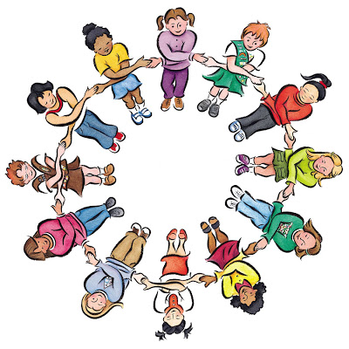
Revised January 2019

Promoting Positive Relationships

Glasgow City Council’s ‘Promoting Positive Behaviour’ articulates our commitment to the inclusion of all children and young people and our belief that they should fulfil their full potential whilst in our care. It has been informed by a range of key national and local documents in particular Glasgow City Council’s revised Additional Support for Learning policy, ‘Every Child is Included’ (2009).

Each establishment is required to produce and keep under a review, a policy on Promoting Positive Behaviour. This policy is derived from the Council’s ‘Promoting Positive Behaviour’ and will take account of the particular circumstances of this establishment.

Our school policy outlines how Cardonald Primary will

• educate the whole child and develop their personal and social skills to ensure their own well being and that of others

• provide safe and stimulating learning environments for all children and young people that enable them to reach their full potential and become successful learners, effective contributors, responsible citizens and confident individuals

• ensure children and young people have regular opportunities to develop an understanding of their rights and responsibilities

• develop an awareness of consequence in children and young people

• develop a desire in all children and young people to participate positively and contribute at all times.

As with all our practice, it is dependent on a successful relationship with parents, carers and our children and young people. I hope you find the contents of this document helpful to you.

Head of Establishment
2. Strategies Employed

Strategies employed to create an engaging and empowering climate for learning


Cardonald Primary School operates a range of initiatives/strategies, which allow the school to promote positive behaviour both at classroom and whole school level. Positive relationships are central to ensuring that young people have the best opportunities to develop, learn and grow.

Building Relationships

‘Developing good relationships and positive behaviour in the classroom, playground and wider community is essential for creating the right environment for effective learning and teaching. Where children and young people feel included, respected, safe and secure and when their achievements and contributions are valued and celebrated, they are more likely to develop self-confidence, resilience and positive views about themselves.’

Better Relationships, Better Behaviour, Better Learning p.5 (2011)

These positive relationships are the foundation for promoting positive behaviour and links to the key aspects of GIRFEC and the Health and Wellbeing agenda. These relationships ensure that staff really know the young people in their care and that the young people have someone the trust to talk to when things are difficult or go wrong.

Nurture

Staff have a responsibility for nurturing and caring for the health and wellbeing of the young people in their care. Staff take time to get to know the young people, connecting with each of them and identifying their strengths and the areas in which they need support.

The nurturing principles are embedded throughout all staff interactions with young people:

1 Children and young people’s learning is understood developmentally.

2. The classroom / school offers a safe base.

3. The importance of nurture for the development of self-esteem.

4. Language is a vital means of communication.

5. All behaviour is communication.

6. The importance of transition in young people’s lives.

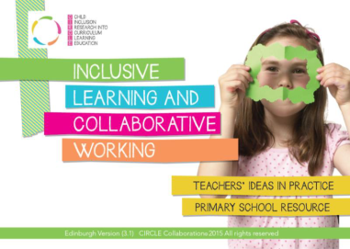

Staff use the CIRCLE inclusive classroom materials to quality assure the learning environment to ensure that universal needs are met. They also use these materials to plan to meet the needs of pupils requiring further specific supports.

https://education.gov.scot/improvement/self-evaluation/Applying%20nurture%20as%20a%20whole%20school%20approach%20-%20A%20framework%20to%20support%20self-evaluation

Health and Wellbeing

At Cardonald all staff have high expectations of children’s behaviour and act as role models for the children. The staff demonstrate openness, honestly, trust, respectfulness and an ability to work with others.


Staff will teach these skills to children through the health and wellbeing curriculum and are aware that some children may need extra support to develop these skills based on their own needs and experiences. We use a variety of resources and partners to support and enhance teaching and learning in this area.

School Vision, Values and Aims

The school promotes positive behaviour through its vision, values and aims. These are explored and promoted through assemblies and woven throughout the ethos of the school.

Our Vision:
Always try your best, as effort brings success.
Our Values:
RESPECT – POSITIVITY – CO-OPERATION-FRIENDSHIP
Our Aims:
In Cardonald Primary we aim to:-
- Provide and promote education of the highest quality
- Encourage each child to maximise potential
- Provide a happy, secure learning environment
- Provide purposeful training and development opportunities for staff
- Promote a good working relationship for all in Cardonald
- Encourage and develop a close home-school partnership
- Encourage pupils to show respect and to value the opinions of others
- Promote equal opportunity for all, regardless of race, gender, colour or religious belief

We use positivity and praise to encourage and motivate pupils to

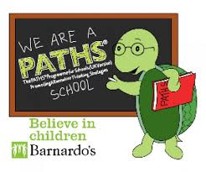
PATHS

PATHS is the resource we use to help develop
social and emotional learning in our children and young people.
PATHS helps improve thinking skills, supports responsible decision making and behaviour as well as helping children achieve overall academic success.

This is an evidence based approach developed initially by Mark Greenberg, Carole Kusche and later adapted by Barnardo’s. We use PATHS as a whole school to ensure consistency, progression and success for all our learners. It also links in with many other aspects of the curriculum.

All children will have a minimum of 2 x 30 min lesson in PATHS per week or 1x 60 min in upper school as appropriate.

PATHS Key Stratgies:

Rules: Children are taught the purpose and importance of rules.

Compliments: Children are taught what a compliment is, why they should pay compliments, how to pay and receive compliments and how they make people feel. PATHS ‘Pupil of the Day’ concept introduces regular complimenting within the classroom.

Calming Down and Self Control: Children are taught a variety of calming down techniques including ‘Doing the Turtle’ and using the Control Signals poster.

Feelings: Children are taught that all feelings are OK (behaviours are OK or NOT OK). Through feelings lessons children develop a better understanding of how to label and recognise their emotions and the emotions of others.

Manners and Fair Play: Lessons teach children the importance of manners and fair play.

Problem Solving: Children learn how to identify and deal with any problems that they may face. Progression through the year groups enable children to work up to using an 11 step problem solving-technique.

Our experience of PATHS has shown us that lessons are most successful when the teacher sensitively adapts and tailors the content of the lessons to meet the needs of the pupils and delivers these in a stimulating and engaging manner, which communicates that the teacher values the lessons.

Restorative Approaches
We are also using restorative practice in partnership with PATHS as an approach to dealing with challenging behaviour and conflict, in line with current Scottish Legislation and Glasgow City Council Policy. Restorative Practice focuses on building and repairing relationships rather than managing and controlling behaviour. It helps develop pro-social behaviours such as empathy, responsibility, problem solving and understanding of consequences.

When considering using restorative approaches it is important to consider appropriate timing of this intervention. If a child is experiencing escalated behaviour then it is important to avoid engaging in direct confrontation which may increase stress levels and provoke a fight or flight response. Giving time and space for a child to calm down can be very helpful, and restorative conversations can be used at a later time, even the next day, to discuss issues and promote improved behaviour.

Where there is persistent challenging behaviour and disruption to learning, class teachers should discuss the situation with SLT directly in a solution-focused manner to identify possible triggers and support strategies. This may involve developing a staged intervention plan at level 1 or 2, based on CIRCLES material. It may also require referral to SIIM for consultative guidance. Where appropriate, teachers will produce a risk assessment document.

PPB and Additional Support Needs

Our school endeavours to ensure that all children and young people, including those who come from vulnerable families and require significant input from partner agencies, will become successful learners, confident individuals, responsible citizens and effective contributors.

We believe that early intervention and a co-ordinated approach by education, social services and health services are essential in enabling the most vulnerable children, young people and their families more choices and chances to achieve.

We ensure that children and young people receive support at levels required to meet their additional support needs by using Glasgow’s Staged Intervention Model. This means that individual pupils may have their own behaviour targets according to their own needs. These targets will be set collaboratively with pupils, parents and carers, school staff and other relevant professionals.

We endeavour to use a range of approaches to meet needs and will use the CIRCLES material to identify approaches, such as visual timetables, safe spaces, social stories, predictabubbles, etc

Respect Me-Anti Bullying Policy
Bullying behaviour will not be tolerated within
Glasgow City Council’s educational establishments.
Below Cardonald Primary’s position statement in accordance with GGC anti-bullying policy and the Scottish Government advice.

Position Statement

All young people in have an entitlement “to work and play in a learning environment in which they feel valued, respected and safe and are free from all forms of abuse, bullying or discrimination.”
(A Standard for Pastoral Care in Glasgow Schools).

This entitlement is in accordance with achieving the key GIRFEC outcomes for Scotland’s young people i.e. that they should be safe, nurtured, healthy, achieving, active, respected, responsible and included. This is also in line with the principles of a Curriculum for Excellence in supporting the development of the four capacities i.e. successful learners, confident individuals, responsible citizens and effective contributors.

Bullying can broadly be defined as any behaviour in which an individual or group exerts power in an abusive or negative way which results in the harming or demeaning of another individual or group. It can be both a process that is repeated over a period of time OR a one off event. People can feel bullied even when those displaying bullying behaviour are not conscious of the harm they are causing or are wilfully seeking to hurt or demean.

Bullying is something which happens in the context of a relationship. It can be subtle or it can be blatant. It can cause short-term suffering or it can go on for years. It can be for clearly identified reasons, such as race, actual or perceived sexual orientation, differences in ability, physique, social class or for no clearly
defined reason. It is always damaging and it must always be taken seriously and addressed. Bullying may be: making BN,M.,
VERBAL As in name calling or making abusive comments
SOCIAL Isolating or excluding another person
WRITTEN For example on paper, graffiti on walls or sent by text or e-mail [including images]
MATERIAL As when possessions are stolen or damaged or when extortion takes place
PSYCHOLOGICAL As when pressure to conform is applied
PHYSICAL As in physical assault
These are just some examples and not an exhaustive list.

Bullying can happen face to face as well as in the virtual world via social media.

The terms ‘bully’ and ‘victim’ are unhelpful terms in that they involve ‘labelling’ or categorising those involved.

Reference should be made instead to “those experiencing bullying behaviour” and “those displaying bullying behaviour”. It is important not to develop predisposed notions about which young person is likely to fall into which category. An individual young person may be both, that is, displaying bullying behaviour in one situation and experiencing it in another. In their relationships with one another, young people may change from day-to-day between ‘friendship’ and ‘bullying’ relationships eg one member of a group may be temporarily excluded and victimised, before relationships heal and the ostracised child/young person is readmitted to the group.
Nevertheless, experience suggests that young people (or indeed older people) who, by virtue of their circumstances, appearance, personality, religion, colour, sexual orientation or other defining characteristics, may appear to be ‘different’ from their peers, tend to be more at risk. Prejudice-based bullying can have further reaching potential impacts as when one’s culture, religion or identity is targeted then other members of that group (family etc) are also targeted by association.

It is important to understand the difference between bullying behaviour and other types of behaviour and how these may overlap e.g. when two people of roughly the same strength (meaning emotional, psychological or physical strength) have a fight or disagreement it may not be bullying but if left unchecked or if there was a change or perceived change in the balance of power it could turn into bullying.
Equally, the ebb and flow of relationships is part and parcel of growing up. Children can fall out of friendships, or find it difficult to maintain friendships. In both these circumstances the role of a caring adult in observing, challenging and supporting young people through these situations is important to ensure a positive experience for all and the development of crucial life skills. G E

Bullying behaviour will not be tolerated within
Cardonald Primary School.

We are committed to reducing the incidence and effects of bullying behaviour according to the following key principles:

• setting an ethos in our school which places an emphasis on respecting, valuing and caring for self and others.
• establishing a climate where all members of our school community, irrespective of age or status, promote and model positive behaviours and values (council employees should note the council’s Employee Harassment Policy).
• taking seriously any report or allegation of bullying behaviour, investigating and taking appropriate action.
• providing support for children/young people who are experiencing bullying behaviour.
• helping the person displaying bullying behaviour to understand the impact of their behaviour and supporting them as they change their behaviour.
• involving parent/carers, as appropriate, in supporting both children/young people who are bullied and those who are displaying bullying behaviour.
• ensuring the level of bullying in our school is monitored and procedures are in place for maintaining a record of any report or allegation of bullying.
• by putting in place quality assurance procedures to monitor the effectiveness of the policy and reviewing as appropriate.

The above will be supported by:

• providing appropriate staff training in recognising and dealing appropriately with acts of bullying.
• ensuring that young people who have experienced bullying behaviour, receive appropriate support and protection from further abuse.
• including anti-bullying education within the Health and Wellbeing Education curriculum for all young people as well as through cross curricular and whole school approaches.
• addressing anti-bullying through circle time and co-operative learning methodologies, assemblies and the class curriculum.

What to do if a member of staff or a parent has a bullying concern:

- If you feel a young personal is being exposed to bullying behaviours this should be reported to a member of the Senior Leadership Team immediately.
- The SLT will carry out an investigation and situations of concern will be closely monitored. This information will be recorded.
- Parents will be informed if appropriate.
- The child experiencing the behaviour will be offered appropriate support as agreed with the parent and school to help them recover from their experience.
- The child displaying bullying behaviours will also be offered appropriate support as agreed with the parent and school to prevent them displaying the behaviours again.
- Any instances of confirmed bullying behaviour will be recorded on the council’s SEEMIS system and the situation monitored accordingly.

T H
At Cardonald Primary we also use a number of other praise and support systems to encourage children to work hard and do well. These include:
Praise could include: | Rewards could include: | Praise should be:
A smile  Verbal praise  Display of work  Showing work to class  Sharing good work in assembly  Sharing good work with another member of staff | Group points  Tokens collected for whole class reward  Smiley face on work  Stickers  Appreciation by other children  Certificates | Personal  Encouraging  Effective  Sincere  Specific  Immediate

Emergency

If a child is behaving in a way that you feel is putting themselves, others or yourself at immediate risk of harm or danger please send for help using the emergency card.

Every classroom has an emergency card – do not be afraid to use it.
If you urgently require a member of management please send this to the office area as the SLT are not always in their offices.
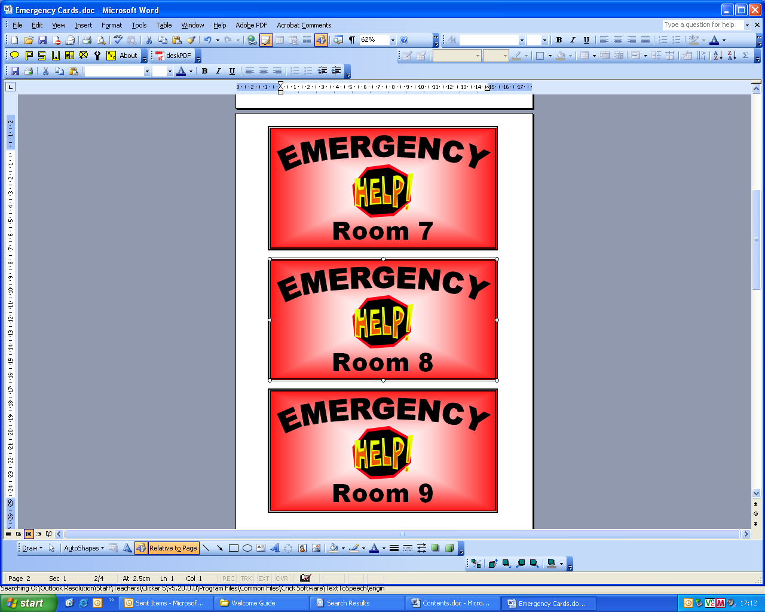

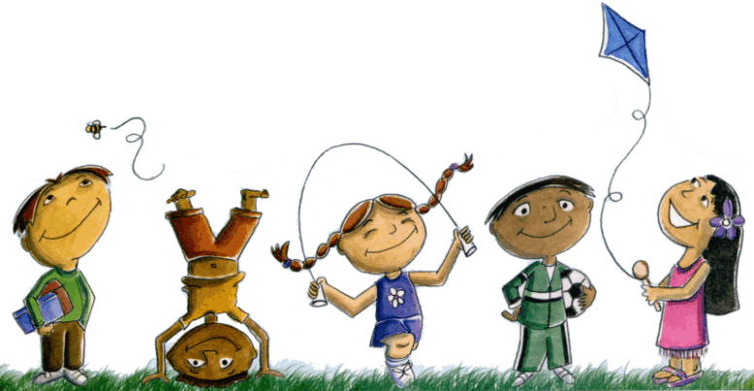

Playground Behaviour

Where a significant incident has taken place during a break time it should be dealt with by Support for Learning Workers or SLT as follows:
- First Aid takes first priority where a child has been harmed.
- SfLWs will use restorative practices to help children resolve minor disputes in the playground/ lunch hall.
- Where children are not calm, they are not able to resolve issues and should be removed to calm space. Incident can be resolved later.
- If there is a physical fight the children should be given time out to calm down.
- If a serious incident takes place, SLT should be summoned immediately.
3. Meeting Learning Needs through Staged Intervention


Meeting Learning Needs through Staged Intervention

Our school ensures that all children and young people, including those who come from vulnerable families and require significant input from partner agencies, will become successful learners, confident individuals, responsible citizens and effective contributors.

We believe that early intervention and a co-ordinated approach by education, social services and health services are essential in enabling the most vulnerable children, young people and their families more choices and chances to achieve.

We ensure that children and young people receive support at levels required to meet their additional support needs by using Glasgow’s Staged Intervention Model.

Stages 1 and 2
Learning needs are met within establishment:

- Differentiated programmes of class work
- Modification to classroom environment and methodology.
- Additional input from Support for Learning Workers e.g. reinforcing keywords, tables, number bonds
- Group/Individual support plans

Stage 3
Teachers, support for learning workers, visiting teachers and other professionals liaise regularly to provide a holistic approach to planning to meet needs through an Additional Support Plan (ASP)

- Modification to classroom environment and methodology.
- WAP (Wellbeing Assessment Plans)
- Developmental P.E. programme
- Social Stories/Comic Strip Conversations
- EAL support for children for whom English is an additional language
- Support from SaLT (Speech and Language Therapy) or Educational Psychology
- Individual support plans
- Block of small group or 1-1 teaching support
Stage 4
A multi-agency approach is taken to plan for children and young people who are vulnerable. This will take the form of an Additional Support Plans, Wellbeing Assessment Plans (WAP) or Co-ordinated Support Plan (CSP)
- Involvement from social work
- Support from NHS health care professionals such as CAMHS (Child and Adolescent Mental Health Services)

3. Approaches to Positive Behaviour

Within our school a range of approaches exists to promote positive behaviour based on improved relationships, engagement, motivation and emotional wellbeing. These include:
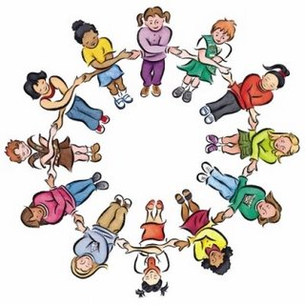
- Solution Oriented Approaches
- Restorative Practice
- Nurturing Principles
- PATHS
- CIRCLES – inclusive practice
- Social Stories
- Comic Strip Conversations
- Circle Time and Golden Time
- ‘Respect Me’ anti-bullying

4. Quality Assurance

The Promoting Positive Behaviour Policy will be monitored and reviewed regularly within the school’s audit and review process. We will use guidance and evidence from:
- Education Scotland’s ‘Journey to Excellence’ guides: HGIOS 4
- Glasgow City Council’s ‘Health Improvement’ self-evaluation toolkit
- Glasgow City Council’s GIRFEC self-evaluation toolkit
- Professional dialogue and discussion
- Learning conversations

Roles and Responsibilities

The Headteacher and Depute Headteacher will:

- Ensure the implementation of local and national policy in a manner which leads to enhanced provision and practice within Cardonald Primary School where all staff are clear about their roles and responsibilities
- Create a climate of mutual respect and of feeling valued, where achievement is celebrated
- Ensure equality and fairness, tolerance and understanding in a consistent manner
- Engage all staff in developing an ethos of achievement by promoting positive behaviour within an agreed system of rewards and sanctions
- Help identify the needs of children and young people and provide a high level of support, as appropriate within Glasgow City Council’s model of staged intervention, allowing them to grow and flourish in a safe environment
- Collaborate with external professionals and engage with parents/carers in ensuring the best possible supports tailored to meet individual needs of children and young people
- Provide access to appropriate CPD opportunities to support all staff as they work with children and young people to realise their potential.
- Identify individual pastoral needs and liaise effectively with Children’s Services, parents/carers to ensure the best possible supports for all children and young people.

Teaching and support staff will:

- Recognise that all achievements are worthy of praise and recognition
- Regard every engagement with children and young people as an opportunity to demonstrate care, set or reinforce boundaries, and to create a positive learning experience.
- Create an inclusive learning environment and ethos.
- Set rules for classrooms, corridors and playgrounds, which are clear, fair, shared and consistent with school policies.
- Ensure a safe, bully-proofed environment for working and playing
- Set a high level of professional conduct and practice in the delivery of lessons.
- Give children and young people clear information about expected learning outcomes and guidance on their progress.

Children and young people will learn to:

- Engage within the classroom and the wider learning environment in order to promote mutual respect and develop individual responsibility
- Embrace the school’s values by following the rules for expected behaviours within Cardonald Primary School
- Give of their very best in all aspects of their school life - developing their potential as successful learners, responsible citizens, effective contributors and confident individuals
- Respect their learning environment, remembering the rights of other learners
- Listen to others and expect to be listened to.

Parents/carers will be encouraged to:

- Communicate positively with Cardonald Primary staff in matters affecting attendance, punctuality, homework and pastoral care
- Reinforce the policy and practice within Cardonald Primary in promoting high standards of conduct and expectation
- Engage positively in the life of the establishment through attendance at reviews, parents meetings, fundraising events and other arranged activities
- Support teaching staff and senior managers in encouraging their children to adhere to all establishment policies, in order to create a positive learning environment
- Work in partnership with staff to help address the needs of their children and develop strategies for ensuring high levels of success.

Appendices

1 | Supporting Positive Behaviour  - Strategies for teachers and support staff
2 | What works for pupils and staff  - Strategies for teachers and support staff
3 | Advice on diffusing confrontations  - Strategies for teachers and support staff
4 | 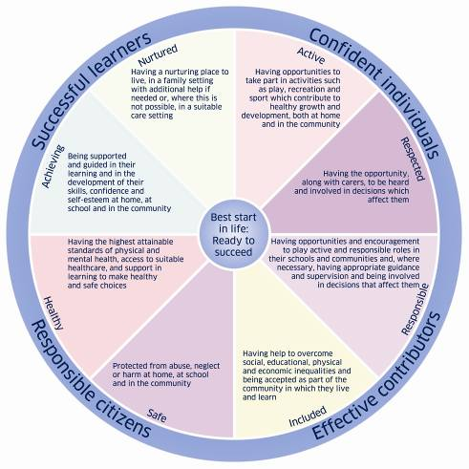  Promoting Positive Behaviour protocol within Cardonald Primary School



Appendix 1: Strategies for teaching and support staff

Planned Ignoring | Children or young people often seek attention with persistent low level disruption, designed to annoy you. As you ignore harmless, undesirable behaviour, it is essential to encourage, point out and praise good behaviours in either the young person or other young people.
Prompting | A reminder can be given to the child or young person to either begin a pre-planned appropriate behaviour, task or response or to stop an inappropriate behaviour, task or response. This can be done verbally with a pre-planned simple statement or non-verbally with a pre-planned action.
Using Esteem Builders | A show of genuine warmth, interest, concern, encouragement or care can be enough to sustain a child or young person through the immediate problem instead of having to act out inappropriately.
Jump Starting | Sometimes it can be obvious that a child or young person is lacking the confidence to begin and/or the motivation to complete a task without help. An adult can provide the confidence to get over the first hurdle and on to learning.
Chunking Tasks | Sometimes, for the child or young person, the task seems insurmountable. An adult can break it down into small, achievable stages.
Side Stepping | A change in the focus or direction of a task or indeed a complete change of task may be enough to distract or divert the child’s or young person’s attention and allow him/her to calm down and to remain in control and de-escalate the situation.
Time Out | Removing a distressed or distressing child or young person to a quiet, private area can help him/her to calm down, discuss the issue, possibly resolve the issue and allow for re-integration to the group.

A glass of water and time to think works wonders!

Appendix 2: What works for pupils


Think about how you like to be treated as an adult and apply this to the way you treat young people in the school

Research tells us that:
One of the single biggest factors in promoting effective positive behaviour strategies is the relationship between the teacher and young person. If the young person feels safe, respected and accepted they are more likely to build resilience to tricky situations.

Research shows us that pupils value:

- Fairness.
- Acceptance and respect.
- Belonging and bonding.
- Choice and shared ownership and involvement.
- Personal responsibility and autonomy.
- Purposeful and challenging school work.
- Confidence.
- Engagement in learning.
- Personal achievement in goals.
- Fun while learning.
- Numerous opportunities for mastery.
- Recognition of effort and success.
- Trust.
- Variety.
- Opportunity to work with others.
- Safety from being embarrassed.
- Understanding strategies for learning and problem solving.
- Connection between learning and outside life.
- Clear rules and procedures that make behavioural and learning expectations explicit.
- Detailed and accurate feedback.
- Extra assistance when needed.
- Minimised competition.
- Teachers with high and accurate expectations of their ability.
- Equity in teacher’s treatment of students.
As class teacher it’s vital that you

Are knowledgeable about pupils | - Get to know your pupils; their background; their current situation  - Get to know each pupil’s likes dislikes/fears/concerns/hopes/ ambitions.
Are empathic | - Actively listen, express concerns/sympathy, and spend time with the young person.  - Recognise your pupils through using their names.  - Show interest in pupils.  - Value and respect them.  - Tune into their emotions and concerns.
Are firm, fair and consistent | - Clear statement of expectations, well defined and clearly understood limits.  - Vary expectations in line with the child’s developmental stage.
Are aware of your own limits | - Know when you are out of your depth, when you need help or support. This should be seen as a strength. Support from other staff is essential when working with challenging children.
Have high expectations | - Share your expectations with pupils.  - Encourage self-improvement.
Collegiate Working  Are assertive | - Seek and act upon the advice of other professionals.  - Use Solution Focused approach to plan appropriate interventions.  - Appear confident.
Are affirming | - Use praise regularly but sparingly with older pupils.  - Catch young people being good.  - Give praise early in a lesson.  - Avoid actions which could spoil the effects of praise.  - Ensure that praise informs.  - Praise for a variety of efforts and achievements.  - Use praise to convey the message: your efforts are paying off.  - Be genuine.  - Be sensitive to the effects of public versus private praise.  - Take account of the forms of praise and rewards that the pupil finds most helpful.  - Use praise to complement effective teaching not to compensate for an inadequate curriculum.

Other strategies to help manage behaviour positively may include the use of the following strategies:

Being humorous | Wit, jokes, making light of, putting on an act, laughing with.
Being persuasive | Negotiate, agree, compromise- remember avoid confrontation.
Being safe | Safety of all is a priority.  - Think safe, act safe, err on the side of safety.
Being observant | Assess the situation quickly.  - Is this really a pupil’s disturbing behaviour or a windup/a set-up?  - Is this behaviour unusual?  - Why might this child be behaving in this way?  - Should I communicate what has happened and if so, with whom?
Being organised | Base your approach on a simple structure:  - Getting pupils into the room.  - Getting pupils started.  - Keep pupils moving.  - Managing transitions.  - Know what is happening.  - Maintain momentum in the lesson.  - Have a sense of timing.  - Consider the classroom layout and environment.  - Give some thought to pupils grouping- ensure a mix of abilities and personalities when organising seating plan.  - Develop some supportive routines.  - Consider the impact of the curriculum.
Being ready for the… | Unexpected, illogical and surprising.
Being persistent | - Follow a situation up.  - Persevere with plans for pupils.  - Establish your authority style.
Being preventative | What can be done to:  - Avoid/avert upset?  - Avoid triggers/ certain situations that may cause pupil to become distressed.  - Minimise the possibility of it reoccurring?
Being communicative | - Speak to colleagues and SMT.  - Use the staff meeting to air your concerns/thoughts/ideas.  - Don’t be frightened to unburden yourself/‘sound off’ to a colleague.  - Share good practice through curricular meeting and staff meetings.

Appendix 3: Advice on diffusing situations

Think about how you like to be treated as an adult
and apply this to the way you treat young people in the school
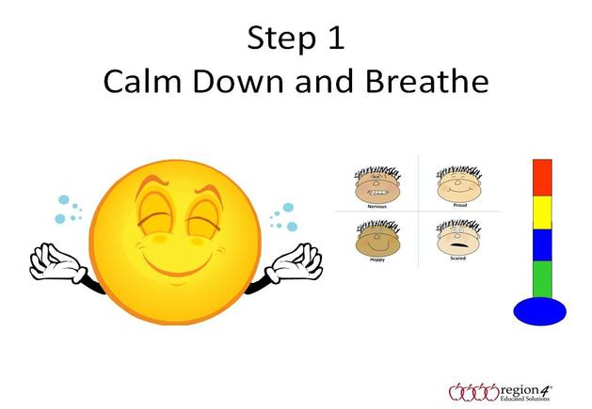
Maintaining rapport | - Keep eye contact.  - Use humour.  - Use distracters to divert attention.  - Sit/stand side on to pupil.  - Have positive expectations.  - Monitor pupil reactions.  - Respect the pupil’s point of view.  - Apologise if appropriate.  - Ask for clarification.  - Give pupil a chance to speak and listen.  - Try to work out pupil’s motive.  - Make only reasonable demands.  - Give frank explanation of consequences.  - Calm pupil’s emotions by mood matching, pacing and leading.  - Use tension releasers, for example unfolding arms; taking jacket off; gentle forward movement; tilting back chair, and so forth.
Staying in control | - Be patient.  - Keep calm.  - Respond rather than react.  - Don’t jump to conclusions.  - Monitor your own feelings.  - Control voice tone/volume/gestures.  - Show anger only if controlled.  - Don’t take yourself too seriously.
Don’t make it worse | - Don’t shout.  - Don’t touch.  - Deal only with the immediate issue.  - Don’t bring up the past-move on from bad experiences and historical issues.  - Don’t personalise the issue.  - Avoid threatening language.  - Avoid threatening gestures.
WHAT NEVER WORKS
- Belittling, demeaning, undervaluing, sarcasm.
- Directly abusive adult behaviours.
- Blocking exits (both physical and mental).
- Misusing information.
- Making statements you cannot deliver on.
- Becoming the victim.
- Losing control or appearing to lose control.
- Showing fear.
- Losing your temper.
- Getting involved in an argument.
- Giving a row/dealing with an issue when you feel genuinely angry and emotional.



Appendix 4: PPR Protocol at Cardonald Primary

The highest standards of behaviour are expected and we pride ourselves on encouraging and rewarding good behaviour.

WHOLE SCHOOL REWARD SYSTEM

In class reward systems

- Each class teacher will have their own personal reward system in place within their class to meet the needs of the young people they work with.
- Each class has a compliments board to record compliments given be staff for behaviours pertaining to our values. These are shared with SLT on a Friday. All staff have a responsibility to notice and comment on good behaviour.

Celebration Assembly
- Celebration assemblies focus on celebrating the school values, the purpose of the curriculum through the four capacities: Successful Learners/Confident Individuals/ Responsible Citizens/ Effective Contributors, Good Work and Achievements. This will happen in the form of two assemblies so that a mixture of P1-P7 pupils are in each assembly. This will demonstrate what the younger pupils can aspire to and add subtle hints of inspiration.

