MICROSOFT TEAMS/HOMEWORK
PARENTS GUIDE

This year, we are going to use Microsoft Teams as a way to share homework. This will help to ensure everyone’s safety during these times as it will minimise items transferring between home and school. Many of our families will be familiar with Teams as we used it during school closures. Class teachers will create a new class team for all class members.
Homework will start on Monday, 24th, August.
- Children can complete tasks at home and share photographs on Teams – Share your work channel. Please do not send in paper copies of work.
- We are continuing to use Sumdog for maths homework. Children can either log in to the Sumdog website or download the Sumdog app onto a device. Children will receive a reminder of their Sumdog login and password details.
- Some children will receive reading books which they bring home. If your child does have a reading book, please return it to school on a Friday to enable us to separate it for 72 hours before re-issuing.
** Children access Microsoft Teams using their Glow email and password details. They will be using the same Glow login and password as last year, e.g. GW19smithjane@glow.sch.uk. If you require a reminder, please email: headteacher@cardonald-pri.glasgow.sch.uk
Primary one children and those new to our school will receive a copy of their Glow details this week.

Please see the guide below, detailing how to access Microsoft Teams:

Part 1 – How to Sign In?

- Use your computer, iPad or phone. Go to Google. Type in “Glow log in” and click on the link (as per the picture below).

- This will take you to your glow log in page (see below). You should enter your glow email address and password. Then click “Sign in”.

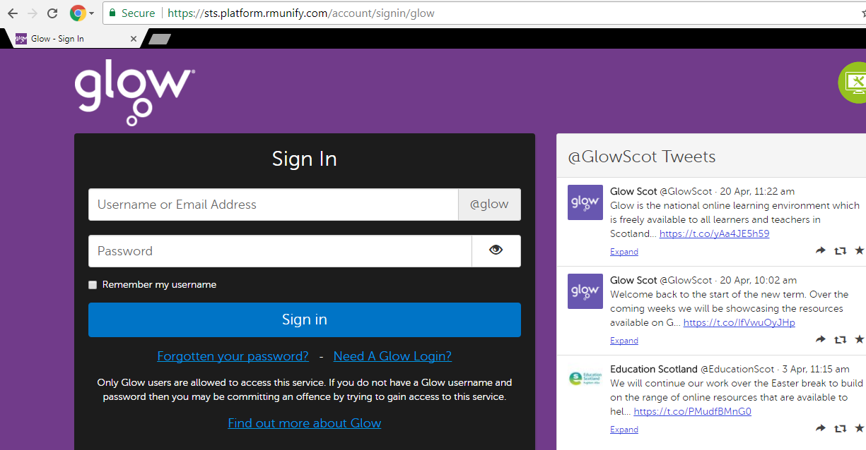

- You will be taken to your Glow “Launch Pad”. The Launch Pad has lots of apps. Make sure you have clicked on to the “school” icon (see below).
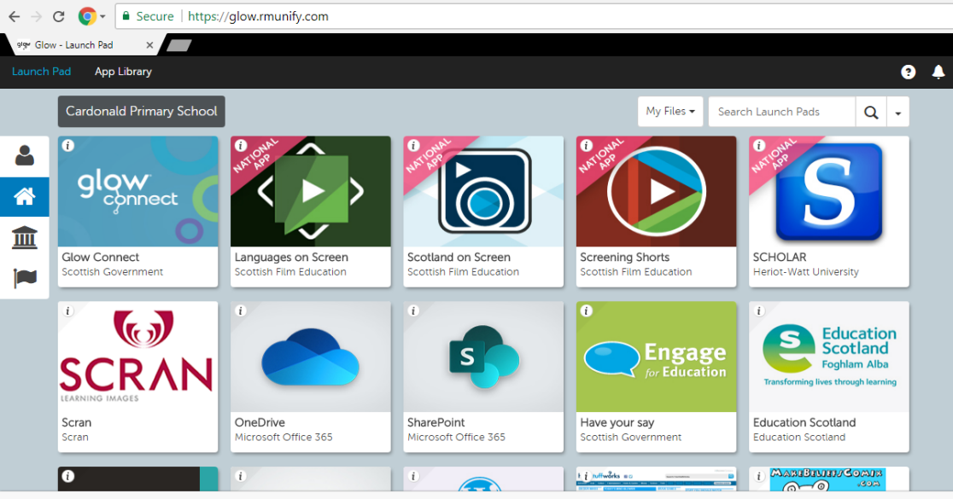

- Scroll through the apps and click the ‘Microsoft Teams’ app (see below). You may be asked if you want to download the app. This is your choice. You do not have to download the app as it will still work in your internet browser.

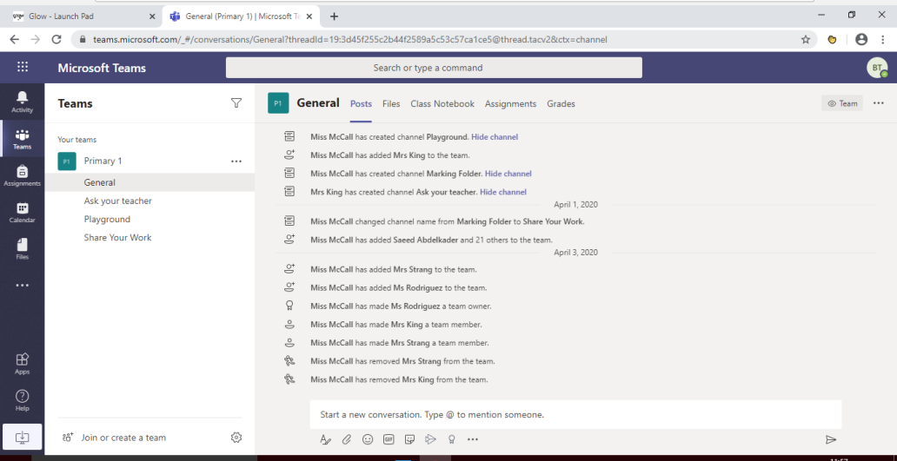
- You should be taken straight on to the Microsoft Teams page (see picture below) and will find your child enrolled in a “team”. A “team” is just their class.

- If it doesn’t take you straight to this page, then it might ask you to sign in again. If it does, then enter your glow email address and password again.

DIFFERENT PARTS OF TEAMS WE WILL BE USING

Make sure you have clicked on the “Teams” tab (see arrow below). The picture below shows an example of the Primary 1 Team.

We have added different “Channels”. A “Channel” is a different area. To access a channel, click on the channel name (see box below).

There are 4 Channels:
General - where teachers will speak to you and set homework.
Ask Your Teacher - any questions for your teacher.
Playground - where children can speak to their class mates. Please remind children to treat their classmates with kindness and respect when chatting on Teams, just as we do in school. Let them know their comments will be seen by everyone.
Share Your Work - This channel has been created so that children can upload homework to share with their teacher. This can be done on a computer, iPad or phone. Don’t start a new post – make sure you follow the instructions below:

How to upload work on the computer:
- Click on the “Share Your Work” channel.
- Click “Posts” (see red arrow below) and you will see areas with each child’s name (see black arrows below). Names will appear where the black lines are.

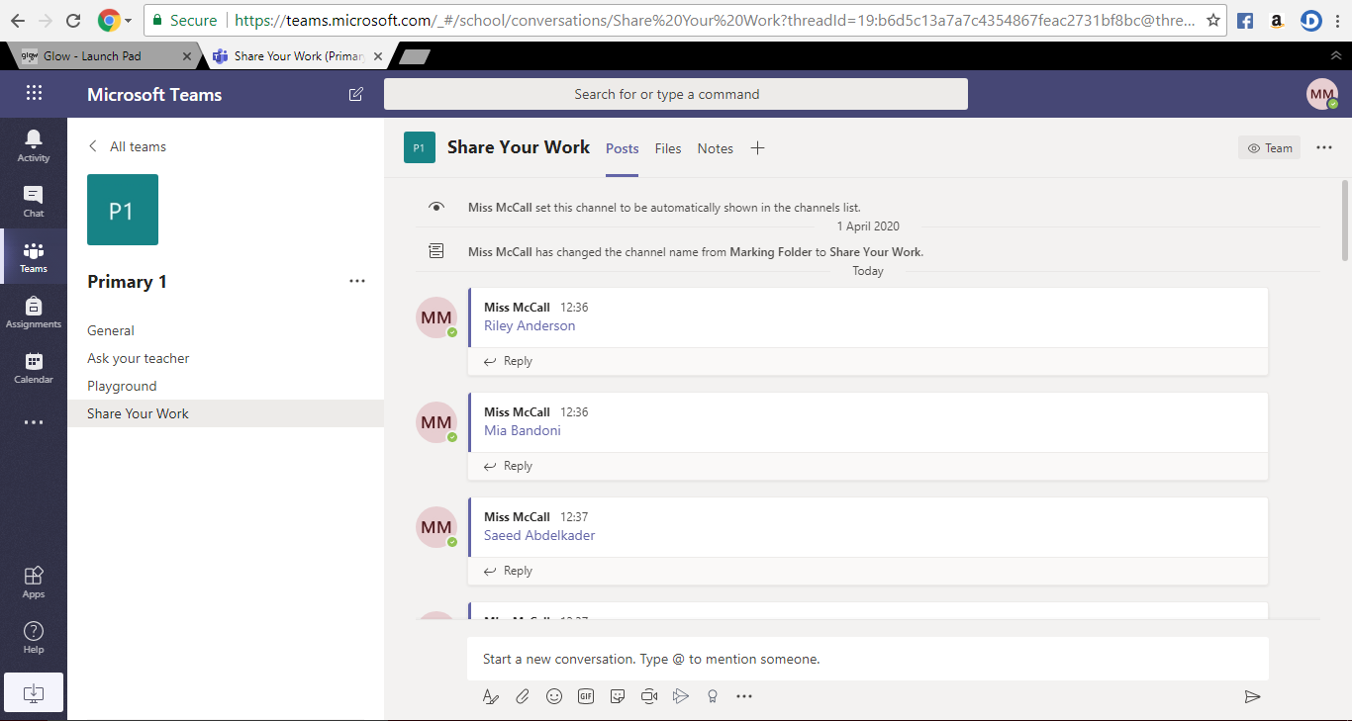

- Find your child’s name and click “reply” (see circles above).
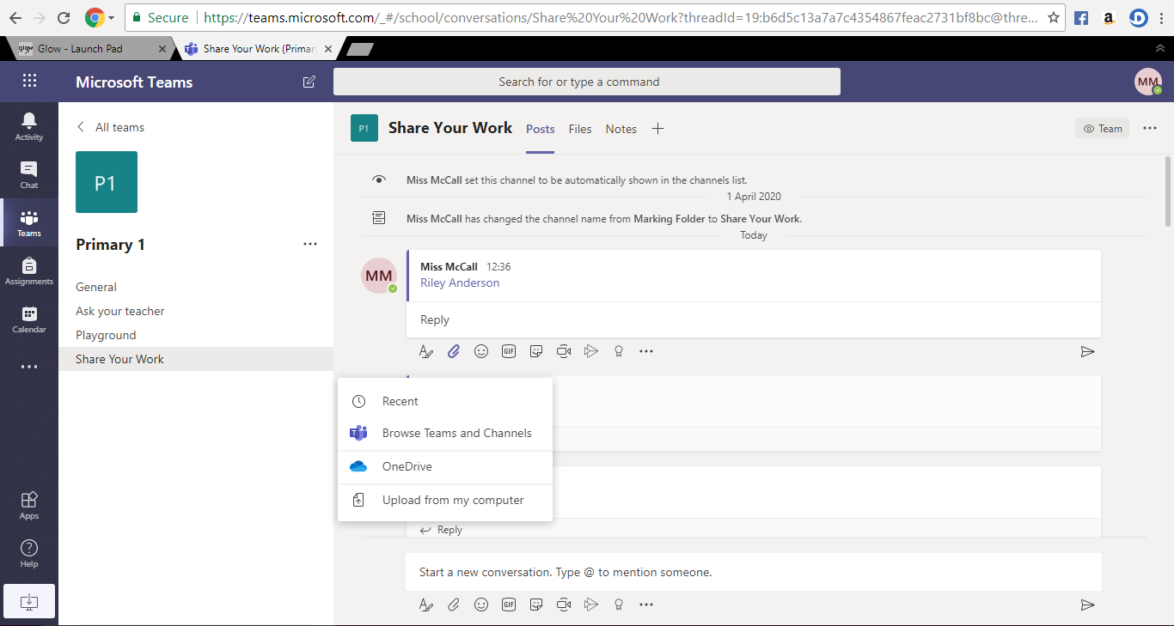
- You can write a comment about an activity you have completed or you can upload a picture of the activity ( see picture below).
- Click “reply” and write a message..
Or
- Click the “attach icon” and click “upload from computer”.
If you are using a phone it should take you straight to your camera roll.
If you are using an ipad you can click the “photo” icon rather than “attach” icon. The photo icon will look like this…

3. Choose the item you wish to upload.

