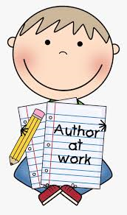Morrison’s Writing Competition!

To celebrate World Book Day, Cardonald Morrisons are hosting a competition for children in our local community. There will be three winners, who will each win a hamper with books, stationery and other goodies! To enter the competition, children should write a story or poem on the theme superheroes.

This is open to their interpretation of what a superhero is to them. The **deadline for entries is Wednesday, 3rd March,** and winners will be announced on Thursday, 4th March.

Parents/Carers should submit a copy of their child's entry, with their name and the school they attend. You can either send via email: [champion.cardonald@morrisonsplc.co.uk](mailto:champion.cardonald@morrisonsplc.co.uk), or Facebook message at Morrisons Cardonald Community Champion.  Alternatively, you can drop the entries off with a member of staff at the store.

Good luck to all of our children who take part!  We have fabulous writers in our school so you are all in with a great chance of winning.

