P1 reading and writing activities

- Read the sentence.
- Copy the sentence.
- Draw a picture about the sentence.
Example
The cat has a hat.
Read “The cat has a hat”.
Copy – The cat has a hat.
Draw a picture -
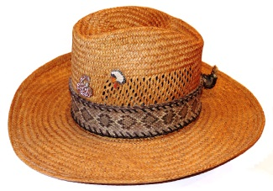
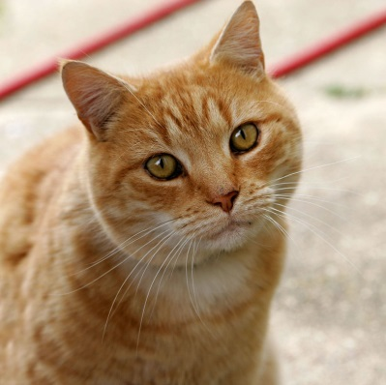
The bat has a hat.

The man is in the van.

The bag has a tag.

The car is red.

Sam likes jam.

Dad is sad.

The net was wet.

The hen is in the den.

The tap had a nap.

