LI: Write out these sentences. Put full stops and capital letters in the correct places.


- amy woke up and went downstairs she
ate her breakfast

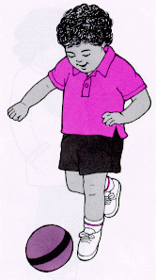

- james kicked his ball he was late for football
club
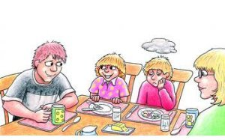

- jack was very hungry he went to eat
his dinner



- charlie saw Sam on the slide in the playground
they were good friends

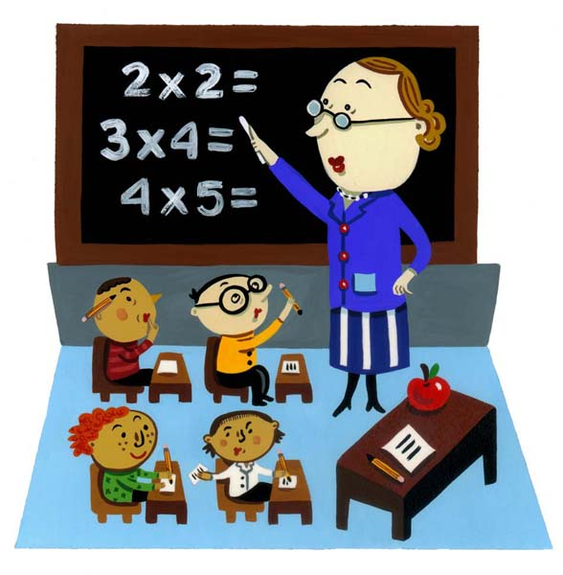

- the teacher was happy that the children had
worked hard she gave them all stickers



- the weather was cold it was warm inside.



- the party was good there were lots of games


- primary 4 won lots of class points they sat nicely. in assembly

